**Dvd10.-**

**“WILL**” in the future

*for predictions:*

Tomorrow it’ll(itol) be cold. Tomorrow it will be cold

It won’t(guount) be sunny. It will not be sunny

*For snap decisions:*

I’ll buy it.

USES OF “**GOING TO**”

*FUTURE INTENTIONS:*

I’m going to learn Portuguese.

He’s going to make a speech.

*AN INEVITABLE RESULT*

Something you can see is about to happen: (Algo que puedes ver está a punto de suceder)

I’m going to miss my train

Be careful! You’re going to lose the match.

The referee's going to send him off the football pitch -> el árbitro lo va a echar del campo de fútbol.

**Simple past irregular verbs**

Buy -> **bought** Come -> **came** do -> **did** drink -> **drank**

Eat -> **ate** find->**found** get-> **got** give -> **gave**

Have-> **had** make->**made** meet-> **met** read-> **read**

Say ->**said** send-> **sent** speak->**spoke** tell->**told**

Think->**thought** write->**wrote** wear **-> wore**

Interrogative (**did)** and negative (**didn’t)** form, the verb “***to be*” don’t use** an auxiliary.

|  |  |  |  |
| --- | --- | --- | --- |
| **Get** -> obtener | **Set** -> establecer, ajustar | **Let** -> dejar | **Give** -> dar, ofrecer, conceder |

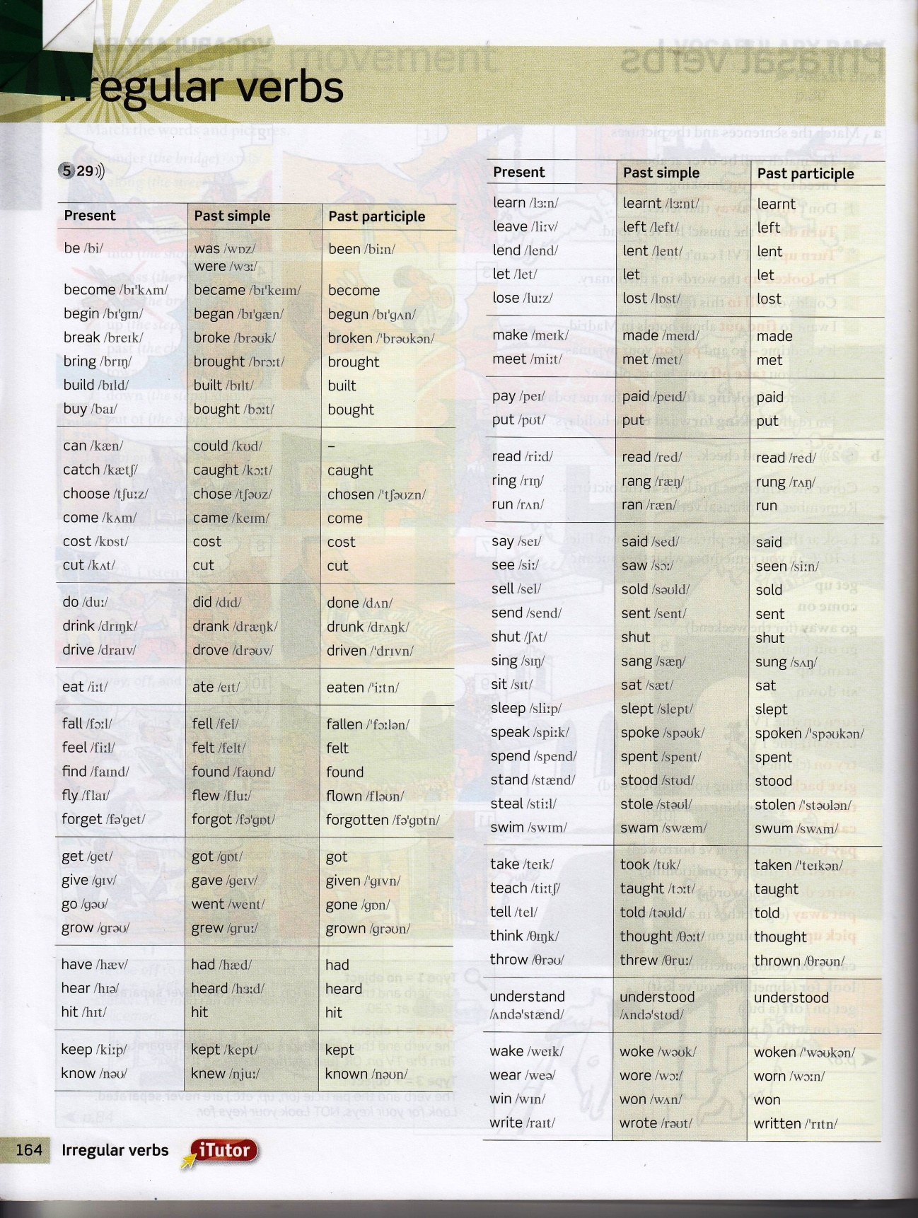

*the question form* **Did**

I **sold /***sould***/** it yesterday -> When did I **sell** /*sell*/it?

I **came** /*queim/* by train -> How did I **come /***cam***/**?

I **had** /*had*/ a problem -> What problem did you **have /***haf***/**?

I **said** /*set*/ that yesterday -> What did you **say /***sei***/**?

I **met** /*met*/ him on Monday -> When did you **meet /***mit***/** him?

I **bought** /*bot*/ it in the England -> Where did you **buy** /*bay*/ it?

I **found** /*faund*/it on the bus -> where did you **find** /*faind*/ it?

I **thought** /*zot*/ it was good -> what did you **think** /*zink*/ about it?

I **flew** /*flu*/ by B.A. -> How did you **fly /***flay***/**?

I **saw** /*sou*/ the film yesterday -> What did you **see /***sii***/** ?

I **drank** /*drank*/ some wine -> what did you **drink /***drink***/** ?

I **took** /*tuk*/ an aspirin -> what did you **take /***teik***/** ?

The diferent uses of “**Like**”:

* **What would you like to do?** -> Que te gustaria hacer. Conditional form(would), Would like expresses desires, wishes and wants-> expresa anhelos, deseos y necesidades

*He’d likes to have a long holiday in the sun -> Le gustaría pasar unas largas vacaciones al sol.*

* **What do you like?** -> Que te gusta. Those are general likes, hobbies

*He likes going to the theatre and the cinema. -> Le gusta ir al teatro y al cine.*

* **What does she look like?** Como es ella?. We’re talking about somebody’s physical appearance: blonde, big eyes, dark skin.

*He’s is dark and handsome -> Es moreno y guapo*

* **What is he like?** “*to be*” with like is the general impression about something, general personality, character: p.e. generous, kind, funny.

*He’s easy going and very generous -> Es tranquilo y muy generoso.*

***How is he?*** *it means only one thing in English is asking about somebody’s general state of health. How a person is feeling (and NOT physical appearance)*

*He’s a bit tired. He’s a bit ….*

**Past continuous tense:**

Past of to be: ***I was, you were, he/she/it was, we were, you were, they were***

It’s used to express an interrupted action, when the action is continuing and is, sometime, interrupter by another action or for example, if you were telling a story:

*Positive form:*

He was sleeping when the lion attacked.

She was working when it happend.

We were watching tv when he phoned.

They were relaxing when the lights went off.

*Negative form:*

I wasn’t concentrating when I dropped it.

You weren’t / gu eant/listening when the teacher explained it.

It wasn’t working when I switched it on.

*Question form*:

What were you doing when he phoned?

Where were you going when the news arrived?

Who were they talking to when I saw them?

**Use “*So*” and “*Such”:***

**Use “*So*” (**asi que, asi, tan, tanto**)**

*So + adjetive:*

Tibet is **so** interesting (extremely interesting)

We were **so** impressed

The monasteries are **so** huge -> los monasterios son tan enormes

**“*Such*” (**tal, semejante, parecido, tanto, tan, que**)**

*Such + adjetive + noun*

*Singular: (***such** **an, such** **a***)*

I was **such** **an** interesting trip -> Fui a un viaje tan interesante

It was **such** **a** different experience -> Fue una experiencia tan diferente

*Plural: (***such***)*

They sang with **such** deep voices

They wore **such** strange hats

***So ->*** *we use with adjectives*

***Such ->*** *we use with the noun and its adjective alright*

**Prepositions:**

|  |  |
| --- | --- |
| **In** -> en / dentro de  **At** -> en  **By** -> en  **From** -> de / desde  **To** -> a / hasta  **On** -> en / sobre / encima  **Under** -> debajo de  **Near** -> cerca de  **In front of** -> delante de  **Behind** -> detras de  **With** -> con  **Without** -> sin  **Between** -> entre  **Opposite** -> enfrente de  **For** -> para  **Next to** -> junto a  **A bit** -> un poco  **A lot** -> mucho  **Ago** /agou/ -> hace  **Yet** -> ya, todavía, aun | **Although** / ôlˈT͟Hō /->aunque  **Instead** /instet/->en lugar de eso  **Even** /ivan/-> incluso  **As far as** /asfaras/ -> hasta  **So far** /soufaa/-> hasta ahora  **So** /sou/ -> asi que  **Suddenly** /sandali/-> de repente  **However** /haueva/-> no obstante  **Perhaps** /pahaps/-> quizás  **What** /uot/-> lo que  **Unless** /an’les/->a menos que, si no  **Still** /stil/-> aun, todavía  **Unlikely to** /anlaikili tu/-> es improbable  **Enough** /inaff/ -> suficiente, bastante  **Maybe** /meibi/ -> quizas  **Rather** -> mas bien, bastante, algo  **Whether** -> si  **Already** // -> ya |

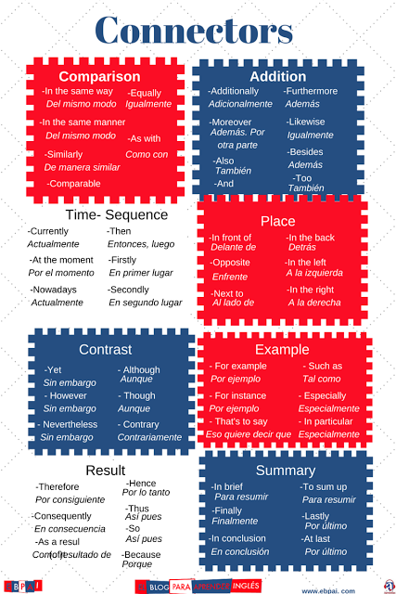

***Vocabulary***

**Ain’t ->** no es, contraction “am not, is not, aren’t”

**e.g. -**> abreviatura for example.

**Loan (to)**-> préstamo, empréstito **Verb**: prestar

**Lend** (to) -> **Verb** prestar, dar, dejar, prestarse

**Borrow** (to) -> **Verb** Pedir prestado, tomar prestado, apropiarse

**I’ll lend you** -> te prestare.

**I'm on my way out** -> estoy en camino de salir

**Won’t** -> will not

**Wont** -> costumbre, acostumbrado

**Starve** -> morir de hambre, privar de comida.

**Forecast**-> predicción, pronostico.

**Cold**-> frio.

**Outbreaks of snow**-> brotes de nieve, comienzo

**Remain** (to)-> **Verb**: permanecer, quedarse, quedar, continuar, comienzo

**Dull** -> aburrido, sordo, embotado

**Rather** -> más bien, bastante, algo

**We'll find out** -> lo descubriremos

**Lack** -> falta, ausencia

**you look a little upset** -> pareces un poco molesto

**engaged** -> comprometido

**Whether** -> si

**Whether or not** -> si o no

**elate** **(to)** -> regocijado **Verb**: regocijar

**Elated** -> exaltado

**I’m elated** -> estoy euforico

**Moody** -> temperamental

**Wanna** -> want to / want a -> quiero

**Now hold on** -> ahora espera

**Pitch** (to) -> campo, paso, tono **Verb** Lanzar

**The football pitch** -> campo de futbol

**Rate** -> tarifa, ritmo, razón, precio

**Quiz**-> examen, acertijo

**Suit** (to)-> traje **Verb** convenir, adaptar, ajustar, acomodar.

**Scarves** -> bufandas

**Care** (to)-> cuidado, atención, asistencia **Verb** cuidar, atender, preocuparse

**Sudden** -> repentino

**Suddenly** -> repetinamente

**Jug (to)**-> jarra **Verb** enchironar, meter, poner

**Jag (to)**-> punta, pua **Verb** rasgar

**Cage ->** jaula

**Spell** (to)->hechizo, encanto, temporada **Verb**: deletrear, escribir, significar

**Meaningful** -> significativo

**But so what** -> y que

**Handle** (to)-> mango, asa **Verb**: encargarse de, manejar

**Die** (to)-> dado, molde **Verb** morir, acabarse

**Grasp (to)** -> **Verb** agarrar

**Drop** (to)-> **Verb**  dejar caer, soltar